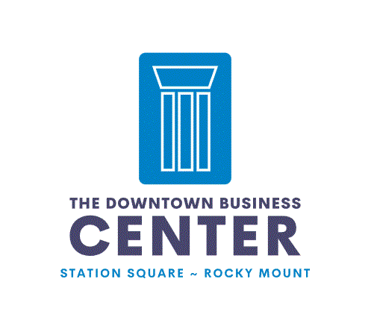

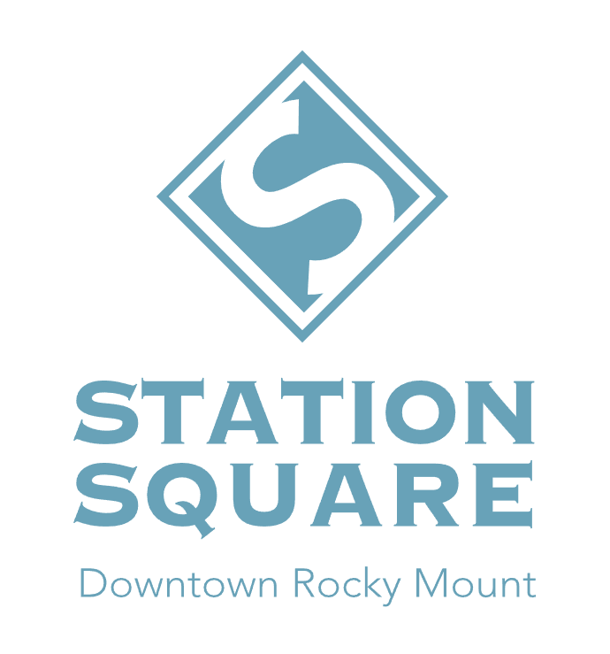
MEMBERSHIP GUIDE & CONTRACT

WELCOME TO THE DOWNTOWN BUSINESS CENTER
Welcome to The Downtown Business Center at Station Square. Our mission is to offer an affordable, collaborative work environment with shared meeting and conference rooms in the heart of Downtown Rocky Mount NC. Included in this Membership Agreement and User’s Manual is a list of resources, rules and tips that will make it easier for new members to get the most out of their experience. For this to occur, all members will agree to the following:

This Membership Agreement and User’s Manual “Agreement”, made on __________________ by _____________________________________________and between Station Square NC hereinafter referred to as “Landlord” and Station Square, located at 301 S. Church St. Suite 10 Rocky Mount, NC 27804 hereinafter referred to as “Member” for the sole use of The Downtown Business Center at Station Square - referred to as “DBC.”

THE DOWNTOWN BUSINESS CENTER

- 136 - Training Room : Capacity 40 people max, 10 people minimum
- 140 - Meeting Room : Capacity 20 people max, 5 people minimum
- The RecRoom : Capacity 50 people max, 15 people minimum
- Bynum Board Room : Capacity 10 people max, 4 people minimum
- Suite 10 Board Room : Capacity 10 people max, 4 people minimum
- Chambliss Collaboration Room : Capacity 4 people max, 1-2 people minimum
- Rabil Collaboration Room : Capacity 4 people max, 1-2 people minimum

The Downtown Business Center at Station Square is an office area located in the Station Square complex. The street address is 301 S. Church St., Rocky Mount, NC. There are three large training rooms, two boardrooms, two small conference rooms and a Podcast Studio. There is access to multiple private restrooms, Downtown eateries and coffee shops and a shared kitchenette to prepare light refreshments. Private offices in Station Square are not a part of the DBC.
MEMBERSHIP FEE: For the 6-month term of the membership, the monthly membership fee is $125.00/month. Members are required to set their payment on monthly draft, and the draft shall be set on the 1st day of each month. If the draft is returned, a penalty of $35.00 will be assessed and will be due with the regular payment. If the member fails to pay any installment of the membership fee on the first day of the month it is due, he or she shall be in default on this agreement and subject to remedies determined by Station Square at its sole discretion. Any accounts not paid for by the 5th of the month shall assess a $5.00 late charge. Should Member desire to continue membership beyond the initial term of (6) six months, membership shall continue month-to-month renewal basis at the current rental rate set by Station Square.
MEMBERSHIP FEE The Downtown Business Center Membership $125.00/month
ONE-TIME USE: Space reservation in the Downtown Business Center at Station Square may be reserved for one-time use business meetings or training at an hourly rate of $75.00/hour.
ONE TIME USE FEE The Downtown Business Center Membership is available for $75.00/hour
RESERVATIONS: Each Downtown Business Center at Station Square member will be using a self-service, web-based booking system called SKEDDA. There is an APP and an on-line web-based option. When the conference room is not being used for a meeting, members may treat it as a multi-person workspace. Reservation will be canceled if you do not confirm your booking 30 minutes prior to use. Please book space according to the capacity listed. Do not book the largest conference room if there is only going to be yourself or a few people. Please be mindful of the space and its capacity.
ELECTRONIC ENTRY: Members will access the main entrance of Station Square on Main St. and Church St. using individually assigned and monitored fob issued upon their acceptance. Members are responsible for always maintaining possession of their fob. Lost or stolen fobs should be reported immediately. Do not lend your fob to other individuals. If a member permanently leaves The Downtown Business Center at Station Square, they’re expected to return their fob in a timely fashion. If you lose your fob, it can be replaced for $25.00 each.
MEMBERSHIPS: Memberships are issued to individuals or companies. Each Member shall pay his or her membership fee separately. Memberships extend for six (6) months from the signing of this Agreement. Members are asked to provide written notice at the end of the term if they should decide to discontinue their membership.
HOURS OF OPERATION: The Downtown Business Center at Station Square is open 24 hours a day, 7 days a week except for on major holidays and twice a year for large events that are co-sponsored by Station Square. (The Station Square Spring Affair & The BBQ Throwdown)
MAIL/DELIVERIES: Virtual Offices are available for an additional $50.00 a month and can be added to your membership. Mailboxes are in the Lobby.
INTERNET: Wi-Fi is available, passwords are posted in each room.
TRASH/CLEANING: There are several trash cans throughout the spaces. Please use them. The cleaning service comes in the evenings during the week however rooms are often in use multiple times a day. We ask that ALL MEMBERS clean up after themselves. There is a vacuum in the storage closet of the 136-Training Room if needed. If you serve any kind of food, you are required to remove all trash, boxed lunches included. See Front Desk if you need a big trash bag and please do not leave any food behind or in the refrigerators.
ROOM SET UP/ CLEAN UP: It is the responsibility of the Downtown Business Center at Station Square Member to allow ample time to set up the space you have reserved as needed. Please always put the room back in good working order. If you borrow additional chairs, tables, or equipment from another space, please return those items so the next user will be able to find what they need. It is NOT the responsibility of the Station Square Staff to have the room preset for your use. We are here to assist you during regular business hours if you need anything. Please advise the Front Desk if something is missing or special attention is required. Basic supplies are available (expo markers, remote batteries, and general cleaning and trash supplies), see the Front Desk.
PARKING: Parking is available in the front parking lot Church St. entrance and on Main St.
EVENTS & NOISE: The Downtown Business Center at Station Square is considered a work environment, and we want you to enjoy interacting with other members. However, members should always be considerate of others and avoid disrupting meetings. The Downtown Business Center at Station Square is NOT to be used for, or rented for Parties, Celebrations, Holiday Activities, or Religious Services outside of the scope of your business. Some events may be approved by Management with previous authorization IF business related. Members may not sublet or allow others to use their membership for any purpose. Immediate dismissal from the Downtown Business Center at Station Square will occur if it does.
SAFETY/SECURITY: Please exercise caution when being here after dark, especially when working alone. If you are working late and feel unsafe, do not hesitate to call the Rocky Mount Police Department, and have an officer escort you to your car or home. The non-emergency number is 252-972-1411. The Downtown Business Center at Station Square is a secure location, but please do not leave belongings unattended for long periods of time, especially overnight. There is a lost and found box at the front desk by the Church St. entrance however, the Landlord assumes no responsibility for lost or stolen items.
SCORE: SCORE is a national organization of retired executives dedicated to helping entrepreneurs and small business owners succeed. SCORE mentors have decades of experience in a wide variety of fields and occupations. If you’re having trouble getting sound advice on a particular subject, they can find someone to help. If you’re interested in speaking with a SCORE mentor, please reach out to markafrohman1@gmail.com for more information.
RELEASE AND INDEMNIFICATION: Station Square is the manager of the Downtown Business Center at Station Square. Signing this Agreement creates a binding relationship between yourself, your executors, administrators, assignees or heirs, and Station Square, where you agree to adhere to the rules and regulations stated above. Station Square reserves the exclusive right to grant, rescind or modify the membership of one or all DBC members, which right shall be exercised in the sole and absolute discretion of Station Square.
In exchange for the right to use the Downtown Business Center at Station Square and related facilities (collectively, the “Premises”) pursuant to this agreement, you (the “Member”), to the fullest extent allowed by law, waive for yourself and your executors, administrators, assignees or heirs, any and all rights and claims for damages, losses, demands and any other actions whatsoever, which may arise against Station Square, and any of its, employees, directors, officers, managers agents, affiliates and contractors, including but not limited to any and all injuries, damages or illnesses suffered by Member and/or Member’s property, which may, in any way whatsoever, arise out of, be related to or be connected with Member’s use of and presence on the Premises. To the fullest extent allowed by law, Member on behalf of himself or herself and his or her executors, administrators, assignees, or heirs, hereby expressly release Station Square and all its, employees, directors, officers, managers agents, affiliates, and contractors from all such claims. Member hereby expressly assumes all risks of entering the Premises and taking part in any activities on the Premises.
To the fullest extent allowed by law, Member agrees to indemnify, hold harmless and defend Station Square and all of its, employees, directors, officers, managers agents, affiliates and contractors from any and all fault, liabilities, costs, expenses, claims, demands or lawsuits arising out of, related to or connected with the Member’s use of and presence on Premises, and should any such fault, liabilities, costs, claims, demands or lawsuit arise or be asserted in any way whatsoever related thereto, whether arising under the laws of the United States, any state, or under any theory of law or equity, Member will indemnify, hold harmless and defend Station Square and all of its, employees, directors, officers, managers agents, affiliates and contractors from any and all costs, expenses or liability including, but not limited to, the cost of any settlement or judgment made or rendered against Station Square and all of its, employees, directors, officers, managers agents, affiliates and contractors, together with all costs of court and other costs or expenses incurred in connection with any such claim, demand or lawsuit, including attorneys’ fees.
All damage or injury to the Downtown Business Center at Station Square caused by any willful act or negligence of the Member, its agents, employees, licensees, contractors, invitees, or visitors, shall be repaired by Landlord at the Member’s sole expense, and Member shall reimburse Landlord for all costs and expenses thus incurred by Landlord within thirty (30) days after receipt of invoice from Landlord.
Members may not erect or install any sign, display, promotional material, or other objects on or about the Downtown Business Center at Station Square and the building in which such premises are located without the prior written consent of Landlord. Further, Member shall not make any alterations, repairs, additions, improvements, or other changes in the Leased Premises without the prior written consent of Landlord. All permanent fixtures, including permanent shelving installed by Member during the term of this Lease, shall be deemed to have attached to the Real Estate and to have become the property of Landlord. Member shall remove any or all such property if Landlord demands that Member effect such removal. If such removal is demanded, the Member shall repair all damages to the Leased Premises and restore such premises to the condition in which they were at the Commencement Date. Members shall not have the right to transfer, mortgage, encumber, assign, or sublease all or any part of the Premises. Member further acknowledges and agrees that he or she has read, understands, and will always abide by this agreement.

As always, if you have any questions about the Downtown Business Center at Station Square, resources, and events, please do not hesitate to contact us!
Email Address

Cell Phone Number
Business Name/ Co-Op Intended Use

The Downtown Business Center at Station Square - Applicant

Ben Braddock - Owner

